Mitsuboshi Chemical Co., Ltd.
23 Maeda-cho Kamigamo Kita-ku
Kyoto 603-8005 Japan
TEL: +81-75-701-2228
FAX: +81-75-701-2205

N-Methylaniline
N-Methylaniline
ID MA
Molecular Weight 107.16
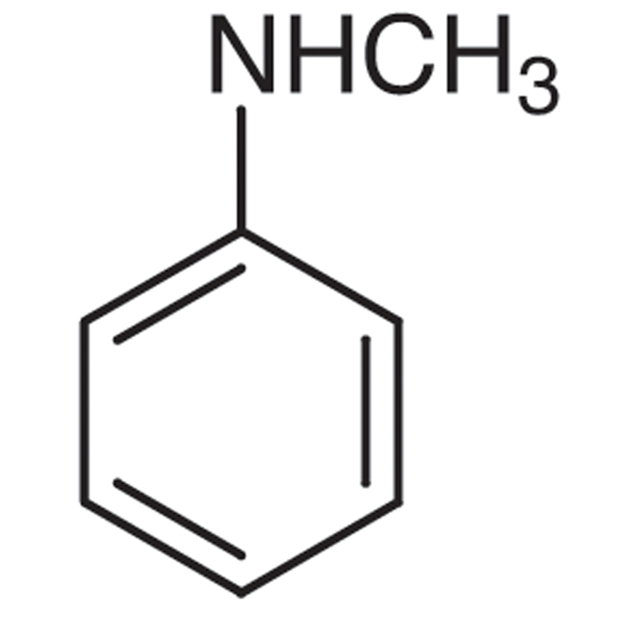

Specification
Purity ％ | ≧99.0
Aniline ％ | ≦0.2
N,N-Dimethylaniline ％ | ≦0.8

Packing Mode Steel drum, contents 195 kgs

